

**LEAD CONNECT WEBSITE DEVELOPMENT PROJECT**

|  |
| --- |
| **Subject:**  ICT301 Information Technology Project 1  **Student Names and IDs:** Amit Bhetuwel, Suyog Adhikari, D M Fahim Faysal, Ramesh, Sakar Tiwari.  **Supervisor Name:** Dr Mubashir Hussain  **External Contact:** Mr.Jagvir Singh |

**KING’S OWN INSTITUTE\***

**Success in Higher Education**

# GROUP ASSIGNMENT COVERSHEET

Subject Code & Name: ICT301 Information Technology Project 1

Lecturer’s/Tutor’s name: Dr Mubashir Hussain

Assignment Title: Group Project Report

## Declaration

(This declaration must be completed by all students in the group or the assignment will not be marked.)

We, the undersigned, certify the following:

* We have read and understood the *Student Academic Misconduct Policy*
* This assignment is our own work based on our personal study and or research.
* We have acknowledged all material and sources used in the preparation of this assignment including any material generated in the course of our employment.
* **The assignment has not previously been submitted for assessment in this or any other unit.**
* We have not copied in part or in whole or otherwise plagiarised the work of other students.
* We have read and understand the criteria used for assessment.
* The assignment is within the word and page limits specified in the unit outline.
* The use of any material in this assignment does not infringe the intellectual property / copyright of a third party.
* We understand that this assignment may undergo electronic detection for plagiarism, and an anonymous copy of the assignment may be retained on the database and used to make comparisons with other assignments in future.
* By completing this coversheet in full and submitting this assignment electronically, we are bound by the conditions of the KOI's *Student Academic Misconduct Policy* and the declaration on this coversheet.

|  |  |  |  |  |  |  |
| --- | --- | --- | --- | --- | --- | --- |
|  | Family Name | Given Name(s) | Student ID | Tutorial  Code | Contribution Percentage | Signature |
| Student 1 | Bhetuwel | Amit | 12100668 | ICT301 | 100% | Amit |
| Student 2 | Adhikari | Suyog | 12000387 | ICT301 | 100% | Suyog |
| Student 3 | Faysal | D M Fahim | 12200828 | ICT301 | 100% | Fahim |
| Student 4 | Dangal | Ramesh | 12203017 | ICT301 | 100% | Ramesh |
| Student 5 | Tiwari | Sakar | 12201041 | ICT301 | 100% | Sakar |

## **Assignment Receipt**

Subject Code & Name: ICT301 Information Technology Project 1 Lecturer’s/Tutor’s Name: Dr Mubashir Hussain

Assignment Title: Group Project Report

|  |  |  |  |  |  |
| --- | --- | --- | --- | --- | --- |
|  | Family Name | Given Name(s) | Student ID | Tutorial/ Code | Signature |
| Student 1 | Bhetuwel | Amit | 12100668 | ICT301 | Amit |
| Student 2 | Adhikari | Suyog | 12000387 | ICT301 | Suyog |
| Student 3 | Faysal | D M Fahim | 12200828 | ICT301 | Fahim |
| Student 4 | Dangal | Ramesh | 12203017 | ICT301 | Ramesh |
| Student 5 | Tiwari | Sakar | 12100668 | ICT301 | Sakar |

GROUP ASSIGNMENT COVER SHEET * AUSTRALIAN INSTITUTE OF BUSINESS AND MANAGEMENT PTY LTD PAGE **1** OF **1**

16 January 2023 CRICOS 03171A ABN: 72 132 629 979

**Executive Summary**

Lead connect is a public benevolent institution (PBI) charity which has a myriad of vision to ameliorate education, social and public welfare. Moreover, this institution focuses to relieve poverty in Western Sydney by organizing various upskilling activities especially to vulnerable Aboriginal and Torres Strait Islander, disengaged youth refugees, asylum seekers, immigrants, and under-privileged women.

This report briefly illustrates the background of the organization, purpose of making charity website, objectives, scope, and limitations. Moreover, this report covers step by step requirement to design prototype of a website which includes, literature and technology review and planning, project planning, requirement analysis, design along with conclusion, recommendation, and future planning. Figma has been used to design wireframe and prototype of the website along with other software. In addition, the colour, front, images, and software for website design has been finalized from couple of meetings with the clients and the final prototype has been finalized.

Contents

GROUP ASSIGNMENT COVERSHEET 2

Declaration 2

**Assignment Receipt** 3

Chapter 1: Introduction 7

Context or Background 7

Purpose 7

Description 7

Objectives 8

Scope and Limitations 8

Scope: 8

Limitations: 8

Chapter 2: Literature and Technology Review and Planning 8

Literature Review 8

Sample Website : Scarf 10

Sample Website: Turbans australia 10

Sample Website: Meca 11

Summary 11

Technology Review 11

Chapter 3: Project Planning 13

Project Design Methodology 13

Project timelines 14

Milestone 14

Gantt Chart: 15

Work Breakdown Structure 16

Work Breakdown Structure of Lead Connect Website 16

Chapter 4: Requirement Analysis 18

User Stories 18

Requirement Gathering 22

Requirement Analysis 25

Functional Requirements 26

Non-Functional Requirements 27

Chapter 5: Design 27

Sitemaps/App map 27

User flow charts/Activity diagram 28

Entity-Relationship diagram 29

User Interface Design 32

UI design kit 32

Low-fidelity design 32

High-fidelity design 36

Prototype 39

Chapter 5: Conclusion, Recommendations and Future Plan 40

Group Activity log…………………………………………………………………………………………………………………………….41

Reference 42

Appendices 42

# Chapter 1: Introduction

## Context or Background

LEAD Connect is a recently formed public benevolent institution (PBI) charity committed to enhancing education, social and public welfare, and poverty alleviation in Western Sydney. LEAD Connect strives to uplift and allow full involvement in the community by empowering disadvantaged and vulnerable populations such as Aboriginal and Torres Strait Islander peoples, disengaged youth, refugees, asylum seekers, immigrants, and their dependents.

The operations of the organization include a variety of methods to meet the needs of the community. LEAD Connect focuses on building marginalized groups' capabilities and life skills, as well as offering relief from poverty and misery. LEAD Connect promotes the governance and efficacy of small service providers, unincorporated volunteer groups, and child and family community organizations by helping and resources, enabling collaboration to address challenges impacting disadvantaged communities.

## Purpose

The purpose of the project is to build a website for Lead Connect, and they area as follows:

* The project involves the implementation of a website for donations for the Lead Connect Company.
* The implemented website should be able to do donations, and also provide advanced
* security to all the users of the system.
* The proposed system should be capable of overlapping with some issues for
* example so many donations at the same time.
* The tracking of the donations should be provided to the donators and a receipt should be provided to them online.
* Education and financial assistance are critical components of LEAD Connects purpose.

## Description

Education and financial assistance are critical components of LEAD Connects purpose. The organization's goal is to close the digital gap by giving access to IT training and lowering the hurdles that disadvantaged Aboriginal and Torres Strait Islander peoples, disengaged youth, asylum seekers, refugees, and immigrants experience. LEAD Connect provides knowledge and inspires individuals to overcome financial issues through several projects.

Furthermore, LEAD Connect educates the community-on-community development through workshops and seminars, providing individuals with the information and skills needed to contribute to the progress of Western Sydney.

LEAD Connect seeks to build a vibrant community in Western Sydney by connecting individuals, organisations, and communities to opportunities, empowerment, and competence. The organisation seeks to guarantee that all citizens may live with dignity, security, and hope, guided by the ideals of inclusion, social justice, education, and equality.

## Objectives

Lead connects, an organization that aims to ameliorate educational standards, public welfare, and eradicate poverty in Western Sydney. There is plethora of objectives of creating Lead connect website which are listed below,

* To build an internet platform that helps to connect with NGOs to bring plan and implement their purpose.
* To create a website offering seamless user experience which is simple and friendly.
* To upload their stories and plan in the website wall for information and motivation.
* To create a Donate feature, by which the organization can collect funds for their planned program.
* To create an form using website, that helps to register applicants who are underprivileged groups like, Aboriginal and Torres Strait Islander peoples, disengaged youth, those seeking asylum, refugees, and immigrants.
* Using the Waterfall methodology for the creation of the website.

## Scope and Limitations

The major limitation of this project is the uncertainty from the client as the Contract is not signed yet and another major limitation is the need for constant communication as the client seems still uncertain about somethings. Along with that not having all of the required resources is also a major issue. And the use of only WordPress for the website is also a major limitation.

### Scope:

* The focus of this project is the creation of a functioning and running website able to accept donation from the users while also providing them with the receipt when the donation is completed.
* This website will include the events, programmes, and everything else, while also allowing volunteers to register for open workshops and events.
* Donors should be able to donate money.
* All the customers who made donation transaction should be notified via mail.

### Limitations:

The major limitation of this project is the limitation of the communication with the client as the meeting can be done only online. Another limitation is the limit of the colour that is only up to seven colours specified by the user are allowed to be used in this website. The website is to be built only by the use of the WordPress which is also a limitation. Even though there are these limitations, they are not a bad thing as they provide us with the basic structure to work out with for this website.

More importantly, even though the website can run on both computer and mobile phones through browsing; there is no separate application available.

# Chapter 2: Literature and Technology Review and Planning

## Literature Review

The literature review has brought sound understanding to determine the functionality of the website. The sample websites like Meca, Turbans4 Australia, and Scarf Refugee Support were analysed and these organizations were also working for different charity purposes. However, the main motto of these websites was similar, that is providing charity for the needy people through various approaches. The designated website of the Client (LEAD CONNECT), and the sample website had a lot of similar features which are designed for the same purpose. After comparing and analysing various features of these websites which are, organisational information, online programmes, blogs, and donation features, it creates a comfortable path us for prototype design and making a functioning website in general.

While comparing the websites it is found that despite being the same charity-based website there were different features among the websites. Each of these websites started featuring their background images with the charity work they have performed. They have used multiple background images, each changing after scrolling down and with a few time intervals. These websites have shared their stories on their home page. In the About Us category, they have mostly included information about their team, management, awards, and recognitions they have achieved. Meca has divided multiple categories service, program, get involved, news and contact. However, the SCARF Refugee Support website has the following pages Get Involved, News Event, and Find Help with various services embedded in one category. Likewise, TURBANS4 Australia, has Home, About Us, What We Do, Volunteer, Contact Us and Donation features. As we can see, these websites have included their programs in the service section of the page. For registering interest in the designed program, Meca has used type form, while another website has used Google form. All of these websites have separate donation buttons for the donation, where there is minor information about the company. This website accepts donations via PayPal, Mastercard and Visa card which are options for donation. Moreover, there is a daily, monthly, and annual donation option for which a personal detail form has been created.

 The websites of MECA, TURBANS4 AUSTRALIA, and SCARF Refugee Support are easy to navigate and scroll around. The functions are well-defined and provide a sound user experience as it has an efficient load time for each section. The URLs are simple, and the various Programmes are easily located on the website. Call-to-actions button in these websites works well and it takes the user to the desired page. These websites have attached their social media account which includes Facebook, Instagram and Twitter. Moreover, SCARF Refugee Support has YouTube to showcase its activities on its webpage. The Page of these websites gets refreshed while clicking on the organization name on the Homepage.

Client’s requirements for LEAD CONNECT mostly match with the features of these sample websites. The discussion at the meeting has led to some planning which includes pages and its design. The sample site map has also been discussed to make a simple website with a user-friendly interface. It also includes About Us, Our Program, and Contact pages. It will also have a donation button for donation features which will be accepted via Visa and master card. In the conclusion, the discussion and analysis on the sample website have made it easier to sketch the charitable website as per the client’s requirement and a clear path for website design is almost broad by now.

* Sample Website : Scarf

### 

### Sample Website: Turbans Australia

### Sample Website: Meca

### 

### Summary

This table shows the comparison of all of the three website that has been identified and applied for the literature review.

|  |  |  |  |
| --- | --- | --- | --- |
|  | **Meca** | **Home turbans for Australia** | **Scarf Refugee Support** |
| **Online Learning Platform** | * Online course * Webinar * Journals and Articles * News and Stories | * No courses * Online collection * News and Stories | * Online courses * Inclusion Training * News and Stories |
| **Social media** | * Facebook * Instagram | * Facebook * Instagram | * Facebook * Instagram * YouTube |
| **Donation feature** | * Donation through Banking transaction. | * Donation through Banking transactions. | * Donation through Banking transactions. |

## Technology Review

In this section, various tools, languages, platforms, and frameworks have been analysed to decide which will be the best for developing the website while also meeting the client’s demands.

WordPress is the most suitable, beneficial, and popular among all the CMS platforms. Some of the reasons WordPress is the most suitable for the creation and enhancement of the Lead Connect Website are as follows:

1. **User-friendliness**: WordPress is a user-friendly content management system that enables the website owner to manage, update and customize the website based on their need irrespective of any specialised knowledge or expertise.
2. **SEO-friendly:** The optimization of search engines can allow a website to be more visible to users on various search engines like Google, Bing, Firefox and more. The WordPress is SEO-friendly, which allows the users to improve the client’s website search engine ranking.
3. **Open source:** The WordPress is an open-source platform, meaning the use and customization of it is free of cost. It is highly user-friendly and allows the creation of the website to be made from scratch without having to pay the fees for a license, allowing our client to save money.
4. **Secure:** WordPress has a strong security system that is updated frequently. This allows the Lead Connect website of our client to have a shield from potential threats. WordPress is used on a global scale by millions of people.

1. **Affordability:** WordPress being an open-source platform where the customization and usability are completely free of cost makes it highly affordable. As the WordPress does not require the client to pay any license fees and allows the website to be built from scratch, this assists us in saving the money of the client.

The development process that will be carried out by our team will be supported by utilising WordPress to develop Lead Connect in a variety of ways. Some of the ways are as follows:

1. **Timesaving:** WordPress has a variety of features and functionalities that are already pre-built and ready to be used. This allows our team to hasten the development process by a huge degree. This allows us to create the website for our client within the deadline or even quicker while meeting the needs and requirements of the clients without having to do everything from the base by writing every single line of code.
2. **Teamwork:** WordPress allows numerous people to edit the same website at once, this will be a huge aid to our team as we are working as a team on this project.
3. **Simple and easy maintenance:** WordPress has a simple interactive design and managing the website is much simpler than coding.

Lastly, the adaptation of WordPress for the creation and future enhancement of the Lead Connect website can have a far higher positive impact on our client and the development process of the website. Some of these advantages which have been mentioned above are Usability, security, affordability, and more.

Summary

|  |  |  |  |
| --- | --- | --- | --- |
| Platform | **WordPress**   * Free, open-source, cross-platform * User-friendly * Free and paid plugins * No compatibility issues * Need to buy hosting | **Joomla**   * Free, open-source, cross-platform * Complex to learn at first * Free and paid plugins * Compatibility issue when various extensions and models are installed. * Need to buy hosting | **Shopify**   * Free, open-source, cross-platform * User-friendly * Shopify’s apps are limited * No compatibility issues * Includes website hosting but more expensive. |
| Plugins | **WordPress**   * Variety of In-built plugins for group forums * Access to huge communities like  [WPBeginner Engage Facebook group](https://www.facebook.com/groups/wpbeginner/) | **Joomla**   * In-built plugin and paid plugins for creation of the group * Access to huge communities. | **Shopify**   * In-built plugin and paid plugins for creation of the group * Access to huge communities. |
| Donation | **PayPal**   * Faster, secure payment processing system * Allows acceptance of online donations * Online Invoicing | **Google Pay**   * Automatic filling of forms * Secure payment info * Frauds alerts to email when sending money * Easy to use privacy control | **Bank Account**   * User-friendly * Secure payment * Online invoicing * Customer support is 24/7 |

# Chapter 3: Project Planning

The project is in a big quantity, so we tried to break down the work into different sections, divide the task among the members, and set the milestone for each period. This website development project has been broken down into different section, so that the sections can be divided among the team members. This has also made it feasible to create a milestone for each of the sections/tasks. The Gantt chart displays the workflow and time taken for completion of the divided sections.

## Project Design Methodology

This project has been designed with the use of the waterfall method. Under which, the steps have been carried out step by step. In this semester, the requirements have been gathered first, then after which the design of the website has been carried out. The implementation, verification, and maintenance will be carried out in the next semester. The main reason for choosing this methodology is the fact that the client is constantly available for the discussion. This allows us to have the requirements, and design fixed and properly at the very beginning phase of the website.

## Project timelines

## Milestone

This is the milestone of the development process of the website.

|  |  |  |  |
| --- | --- | --- | --- |
| * Chapters | Responsibilities/Tasks | Due date | Expected outcome |
| Introduction | All team members | /03/08/2023 | Completed |
| Industry agreement | All team members | 5/08/2023 | Completed |
| Proposal Submission | All team members | 14/082023 | Completed |
| Literature and Technology Review | All team members | 12/08/2023 | Completed |
| Requirement gathering | All team members | 24/08/2023 | Completed |
| Prototype Design (Interface Design, Database Design, Flowchart Design) | All team members | 10/09/2023 | Completed |
| Final Project Report | All team members | 17/09/2023 | Completed |

.

## Gantt Chart:

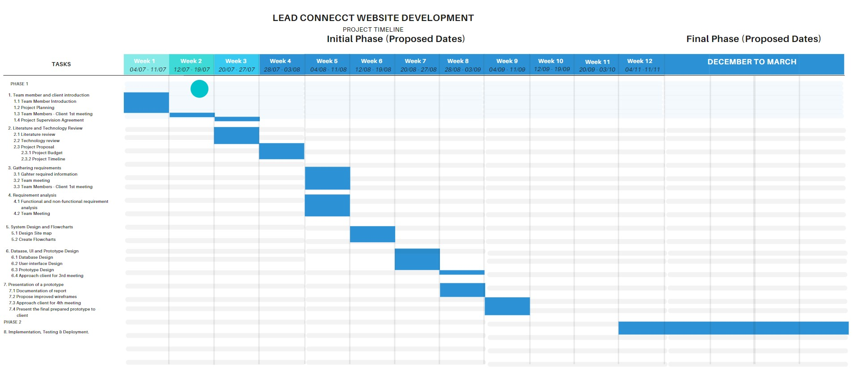

## Work Breakdown Structure

The work breakdown structure (WBS) is a visual breakdown of the project. Initializing with the scope of the work, the WBS shows the deliverables and how they connect back to overarching project. The work breakdown structure of our project is as follows:

### Work Breakdown Structure of Lead Connect Website

|  |  |  |
| --- | --- | --- |
| **WBS** | **TASK** | **DURATION** |
| **1.** | **Literature and Technology Review** | **10 days** |
| **1.1** | **Information gathering** | **7 days** |
| **1.2** | **Create Literature and Technology Review** | **5 days** |
| **2.** | **Project Proposal** | **13 days** |
| **2.1** | **Requirement Gathering** | **7 days** |
| **2.2** | **Create Project Proposal** | **3 days** |
| **3.** | **Database Design** | **6 days** |
| **3.1** | **Information gathering** | **3 days** |
| **73.2** | **Gather information** | **3 days** |
| **4.** | **Flow chart design** | **3 days** |
| **4.1** | **Information gathering** | **5 days** |
| **4.2** | **Create flow chart** | **2 days** |
| **5.** | **Prototype design** | **12 days** |

WBS Name: Website Design

Description: Creation of the design for the website

Completion Date: 17/09/2023

**Project Budget Summary**

**Objective:** Our aim is to complete this project which little to no cost.

|  |  |
| --- | --- |
| **ITEM** | **COST RANGE** |
| Website Hosting | $5 - $20  (DONE) |
| Domain | $10 - $20 |
| Payment System | % of earnings + per transaction fee |
| Premium WordPress account | $120 Annually |
| Plugins and Themes | Varying price |
| Developer fee | $0 |

The costs mentioned above are subjective of change on the basis of needs and requirements. The development and implementation of the website can incur additional costs. Any charges to the budget will be thoroughly and in-detail discussed with the client and will only be implemented after gaining the approval of the client.

# Chapter 4: Requirement Analysis

## User Stories

## Requirement Gathering

These requirements were gathered after going through multiple meetings with the clinets online in order to understand what are the desires of the client. Some of the major requirements whose answers were gathered are as follows:

* User types: Admin, Customer/Donor
* Homepage Items: About the company; Some major events, a brief description of the company, and some pictures of its’ members
* Headers, and footers of the website
* The colour codes that the client wishes to have inn the website. There were altogether seven of them.
* Login page: For admin only;
* Events page: Ongoing events and announcement needs to be mentioned here
* Volunteer page: Ongoing workshop which are accepting volunteers

## Requirement Analysis

**Use Case Diagram:**

This is the use case diagram of the Lead Connect website based on which the relationship in the website with different sorts of user is carried out. And this has been done on the basis of the analysis of the gathered requirements.

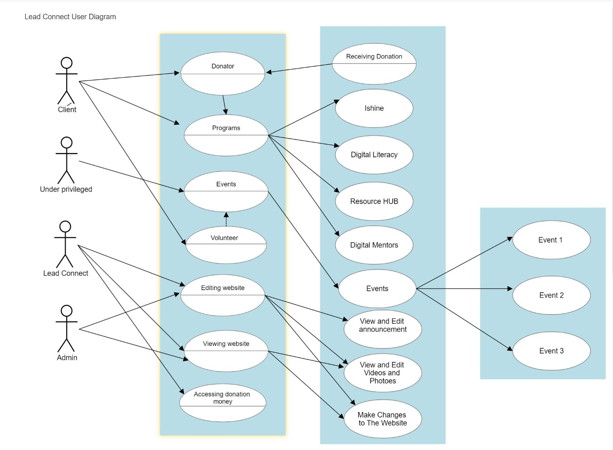

## Functional Requirements

Functional requirements are features of the Lead Connect Website that the developers must implement to allow the users to achieve their goals. The requirements need to be clear, simple, and unambiguous. Some of the examples of functional requirements are:

* Create HOME, ABOUT US, OUR PROGRAMS, CONTACT US, ANNOUNCEMENT AND EVENTS, AND VOLUNTEERS.
* Inform users about the organization’s vision, mission, and values in the about us section.
* Provide detailed information about team members and stakeholders of the organization.
* Provide information about the organization’s motto and constitution.
* Give information about Ishine in the Our Program page in detail.
* Post Blogs, images, and videos of digital literacy in Digital Literacy section.
* Give information about available resources to the under privileged people and its information in resource hub section.
* Provide location and map in Navigation section about organization location.
* Create a contact form that collect the information of the users and helps to make communication.
* Blog about the organization, its programs, and future.
* Create an announcement section and create a pop-up feature for announcements.
* Create a past event section that allocates the past resources, information, images, and videos of past events.
* Future event section also allocates information about its future event information and its detail.
* Create a donate feature for donation.
* The donation section asks for personal and card details.
* Ask donators on donation options (weekly, monthly, or annually).
* Correct information and sufficient funds make successful donations and gives receipt to the donators.
* The Volunteer section gives information about the program when volunteers can register their interest.
* Create and upload a volunteer profile which requires personal and contact information.
* Correct personal and contact details make the registration successful.
* Provide Information about the organization’s past programs.
* Regular improved and updated information on the website wall

## Non-Functional Requirements

Non-functional Requirements (NFRs) refers to the qualities of the system that guides the design of the solution and often is utilized to serve as constraints across the relevant backlogs. While the functional requirements specified how the system responds to specific inputs, the nonfunctional requirements are used to specify various system qualities and attributes, such as:

* Fast and reliable in operation.
* User Friendly, appealing design and easy to navigate.
* Reliability and availability
* Data security and validation
* Make an easy navigating interface and easily readable content.

# Chapter 5: Design

## Sitemaps/App map

## User flow charts/Activity diagram

## Entity-Relationship diagram

In the Lead Connect group, Admin has user account which includes attributes such as full name, email, password. An admin can access account when using login credentials, it should include input such as email and password.

For events & announcements, an event entity must include attributes such as ID, title, description, date & time, location. And an announcement must include title, description, date & time. An admin can create and edit events and announcements. Users are the one who can access the website, register for volunteer program, and make donation. Moreover, the donation can be processed by users which has amount, type, and frequency options.

**Entities identified:**

* Admin: stores admin user information.
* User: who access the website.
* Event: stores event details.
* Announcement: stores announcement details.
* Volunteer- who volunteer the events.
* Programs- Programs launched by organization.
* Donation- collects the fund donated by individuals.

**Entity Relationship Diagram:**

## User Interface Design

### UI design kit

### Low-fidelity design

HOME PAGE:

ABOUT PAGE:

DONATION PAGE:

EVENTS PAGE:

VOLUNTEER PAGE:

OUR PROGRAMS:

### High-fidelity design

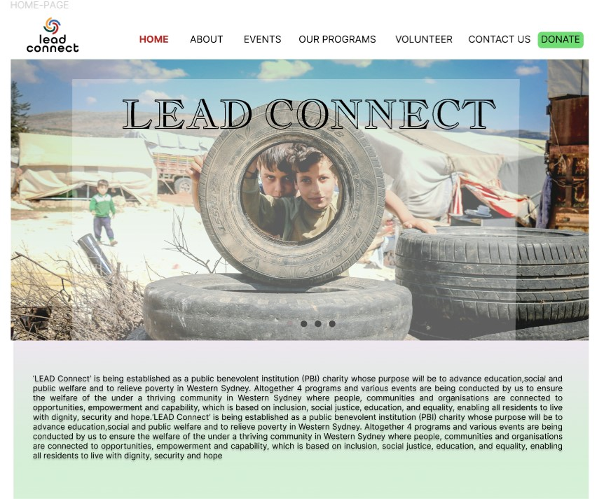

HOMEPAGE (Contd.)

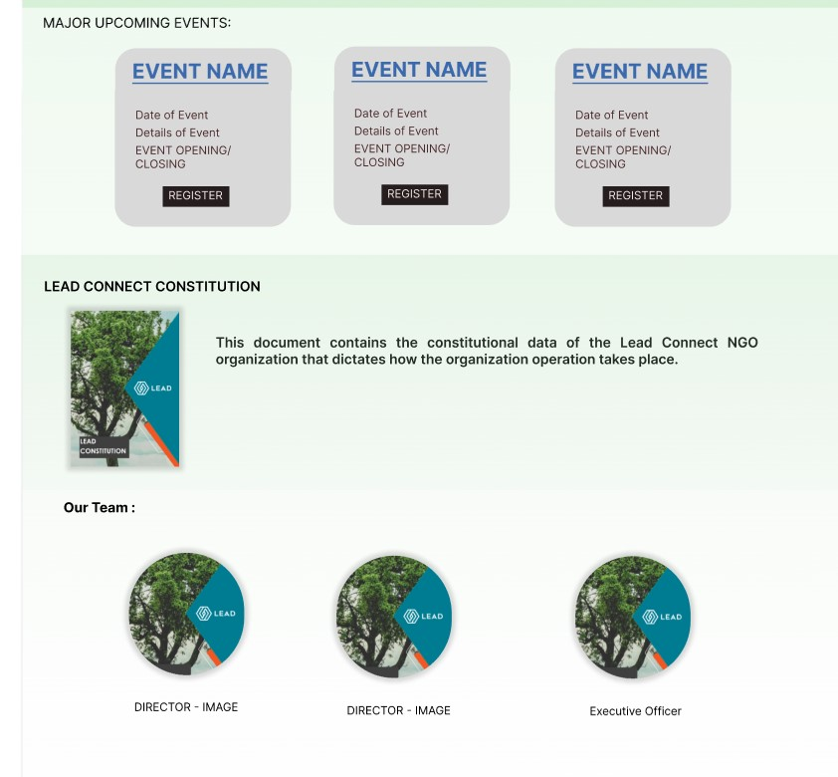

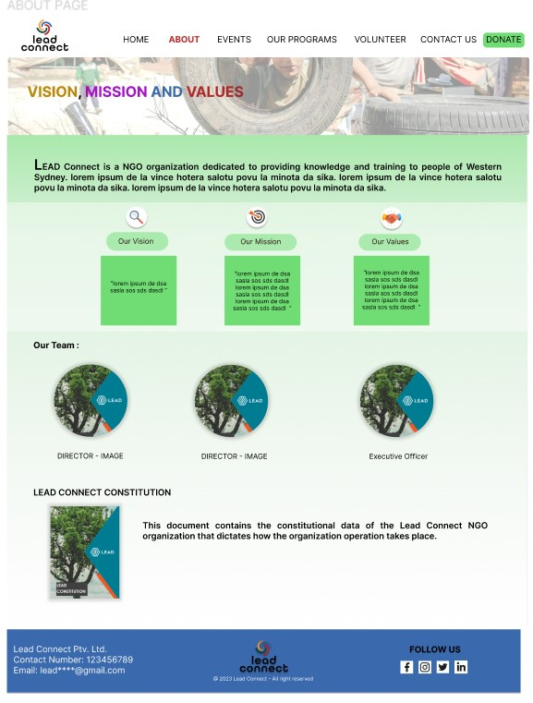

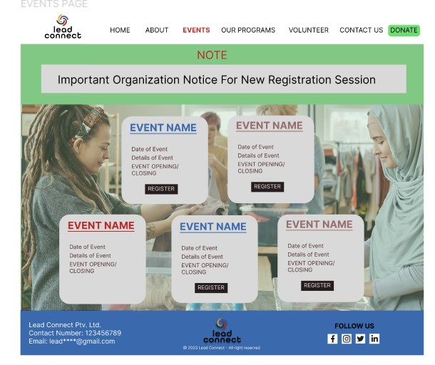

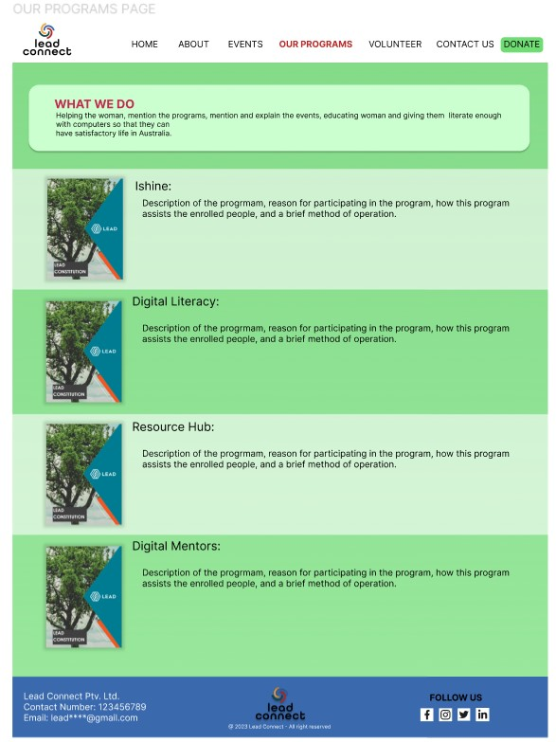

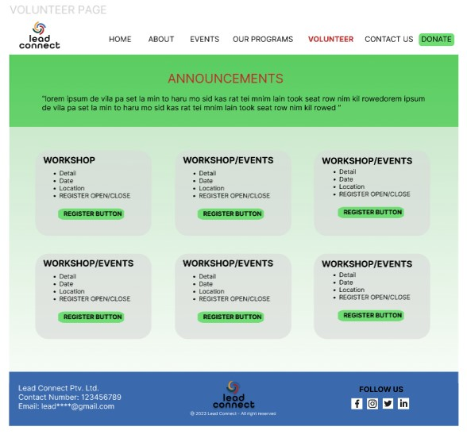

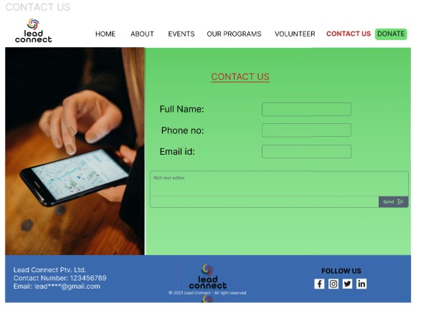

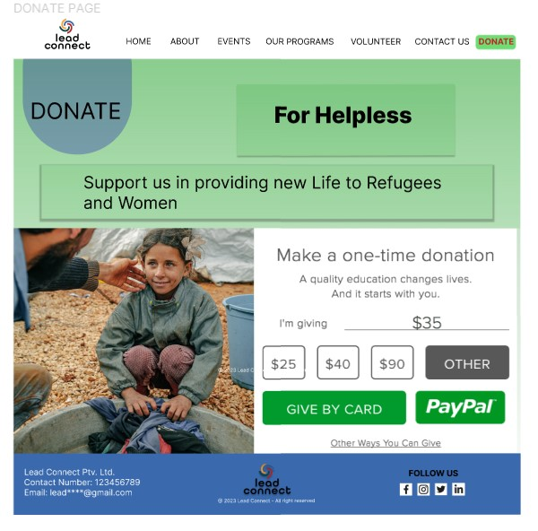

# Chapter 5: Conclusion, Recommendations and Future Plan

**Conclusion**

LEAD Connects initiative to uplift and empower marginalized communities in Western Sydney is commendable, and the comprehensive project plan. More the requirements laid out above provides a solid foundation for the development of an effective and impactful website. With careful execution and a commitment to the outlined goals, LEAD Connect can make a significant difference in the lives of those it aims to serve. The website which is going to be developed can be pivotal

**Recommendation**

* Registration of program can be done online to make easy and efficient.
* Videos and photos of the organization can be shared to make pop-up for interaction on the website.
* Organization can also include feedback option for users to make a comment.
* Review of program can be included on the website to insight the analytics of the programs.
* Moving forward organization can use various tools to modify and ameliorate this website as website design form WordPress is limited.

**Future Plan of the project**

* Any reasonable changes from the client’s needs to be adhered.
* The website prototype created during phase 1 needs to be followed up on and implemented.
* The backend part of the website; meaning the database needs to be functional.
* The website should run smoothly, and all the added plugins need to be working.
* The website should be developed within the budget limit and time that has been discussed with the client.

**Group Activity log**

|  |  |  |
| --- | --- | --- |
| **Week** | **Team Members Present** | **Activity** |
| 1 | Everyone | In week 1, the group was formed. We introduced each other and we also got our project. |
| 2 | Everyone | In week 2, We got the introduction to this subject from Teacher like what we need to do what will be doing during this semester. We learned about project scope, and background. We also discussed about our first meeting with the client. |
| 3 | Everyone | In week 3, we learned about technology and literature review. We started working on the project tasks. We also had our first meeting with client. |
| 4 | Everyone | In week 4, we worked on a functional and non-functional gathering, and we found good resources to take idea for this. We also got a information from client and we knew more about project. |
| 5 | Everyone | In week 5, We learned about requirement analysis, and we started on finishing proposal for the project to submit for the client. We also created some ideas for user stories. |
| 6 | Everyone | In week 6, We finally entered on a system design which was main part for this project such as sitemap, flowchart, database design and prototype. We also discussed about meeting with client and got more ideas to the project. |
| 7 | Everyone | In week 7, we sent proposal to the client. We learned about ER diagrams. We also made ER diagram for our project and with relationships with each entities. |
| 8 | Everyone | In week 8, Our teacher gave us idea about UI design and wireframes. He also suggested We also had a third meeting with client. |
| 9 | Everyone | In week 9, we learned on prototype by using figma tool and we got the basics of digital prototyping, and we also watched some videos about prototyping. |
| 10 | Everyone | In week 10, we started working on report writing. We had a template of report writing.  We also watched project brief for phase II. |
| 11 | Everyone | In week 11, This week was a big week for us because we need to finalise all the tasks. Firstly we combine all our tasks into report and we also made a presentation slides and we divide our parts for the presentation. |

Alongside this, we were using WhatsApp for communicating with each other. And everyone was always available and helpful with the suggestions. And moreover, everyone was present in all of the zoom meeting with the clients, which led to everyone being on the same page when doing the project. This became a tremendous thing as everyone knew what to do in their respective parts. And about how all of this allowed us to make a positive impression on the client.

# References

Figma: <https://www.figma.com/file/YQq4j7W8b2vE5KE8kw5f4O/Untitled?type=design&node-id=0-1&mode=design&t=5PIUxOUwaTFp8nLO-0>

Google Drive: <https://drive.google.com/drive/u/1/folders/1tQIo22341k7qldBUCzwdSDbNjKM8O8MD>

WordPress: < <https://wordpress.com/setup/site-setup/designSetup?siteSlug=webp4.wordpress.com&siteId=223412996&theme=fewer>>

Shopify: < <https://www.shopify.com/au/free-trial?term=shopify&adid=580963306555&campaignid=20414239182&branded_enterprise=1&BOID=brand&gclid=Cj0KCQjw9fqnBhDSARIsAHlcQYQMC8fh1UjV63KQR35KqGXEYvBs9QD0hA9HjMxSTGcVD40DM61m1LcaApuWEALw_wcB&cmadid=516752911;cmadvertiserid=10730501;cmcampaignid=26990768;cmplacementid=324495076;cmcreativeid=163722649;cmsiteid=5500011>>

Smart Draw: < <https://app.smartdraw.com/editor.aspx?templateId=da34e096-b9cb-4d56-a0ce-d9bdef138714&flags=128>>

# Appendices

https://www.meca.org.au/

https://www.scarfsupport.org.au/

http://www.t4a.org.au/

## Prototype

This link of prototype video is attached below,

https://drive.google.com/file/d/1DcjO9huRRQ-KN8W3nToHYnL9M3lFzlea/view?usp=drive_link